# Contributions of team members

There are five members in the group, and in practice 4 participated in building files for this final project:

**Chengjun Liu:**

Take all duties (nearly the whole final project) not belonging to Divya and Jingyi:

* Write nearly all pages (over 17 pages) of the final report, produce all tables & plots and edit grammar, sentences, and wording
* Design all the structure and ideas of the final reports, including opportunities for improvement, result analysis, and recommendations
* Design the formulation and ideas of data, decision variables, and objective
* Build the sample input file
* Design, build and test the whole optimization tool and output sample output
* Write the documentation of tables, plots, formulations, and the optimization tools

**Divya Sripathy:**

Write around half of Chapter 1 of Executive Summary of the project report.

**Jingyi Zhu:**

Write around half of the first point of Appropriateness of Methodology in Chapter 5 of Discussion of the project report.

**Alex Son:**

Edits of grammar, sentences, and wording for the project report before submission.

Below is the part Divya Sripathy writes:

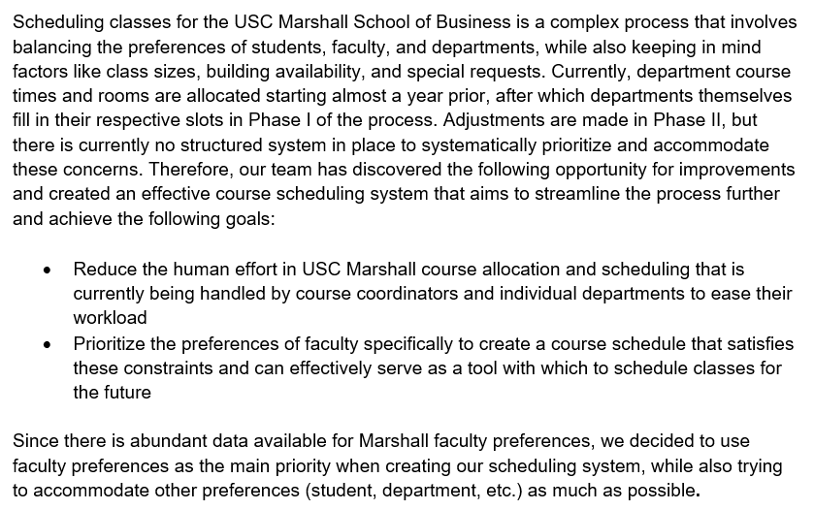

Below is the part Jingyi Zhu writes:

